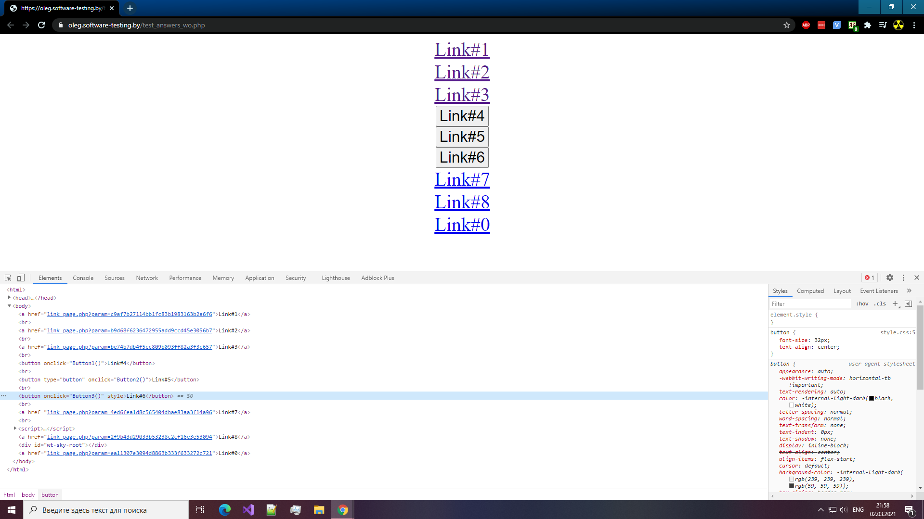

Link#0 - 502 Bad Gateway

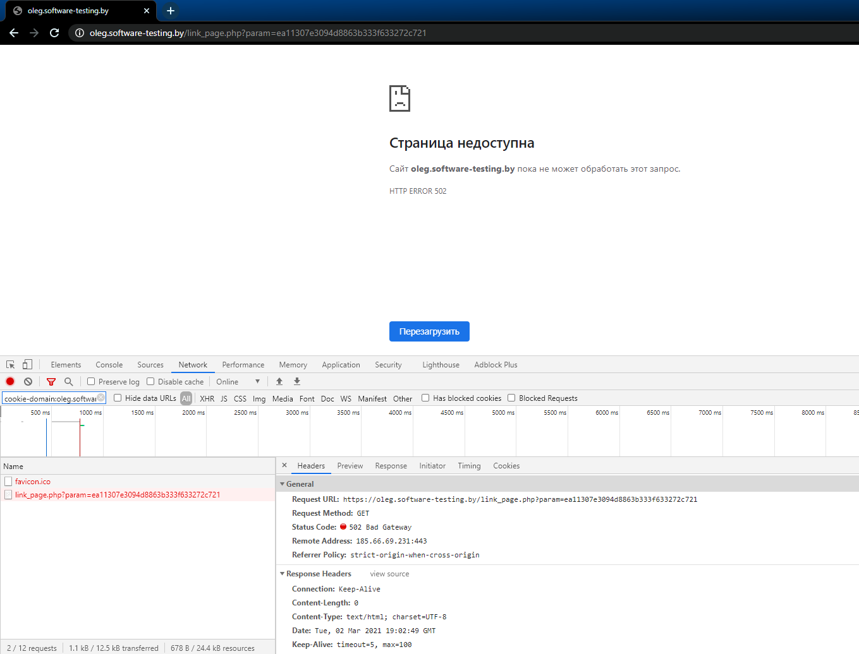

Link#1 - 301 Moved Permanently

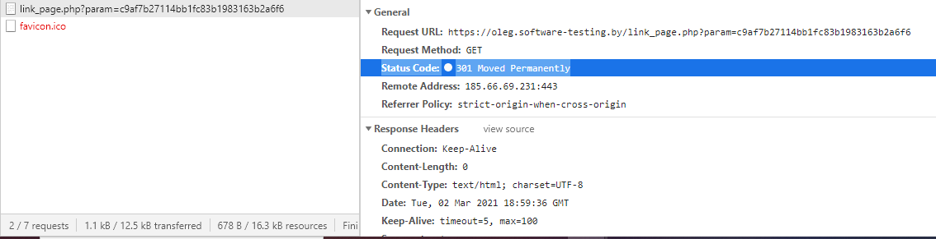

Link#2 - 302 Found

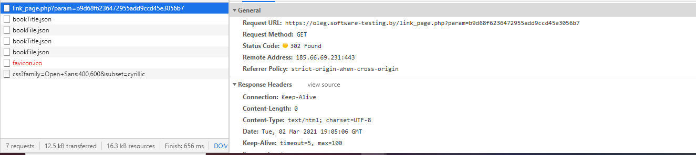

Link#3 - 200 OK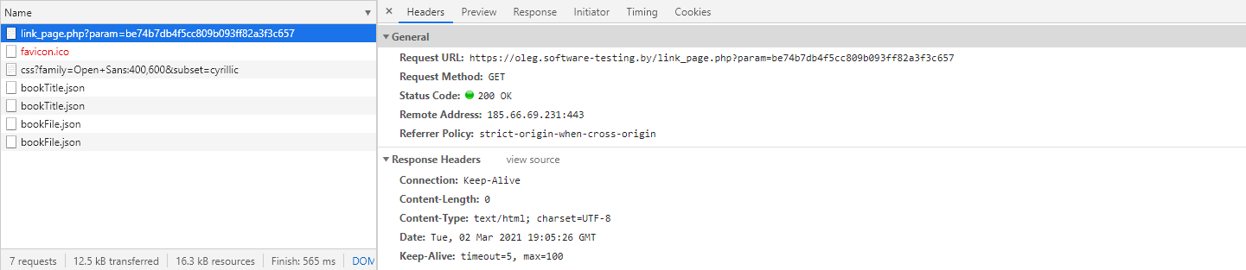

Link#4 - 500 Internal server error

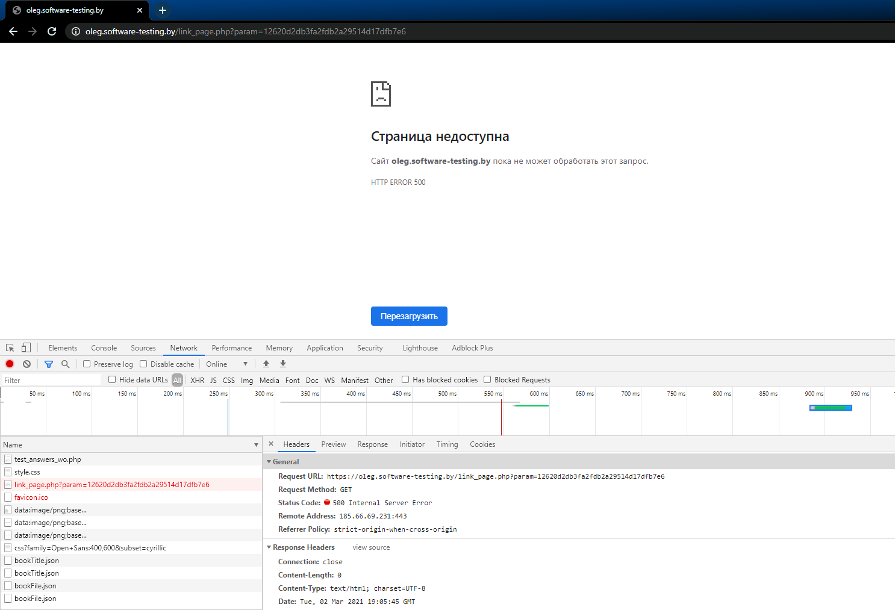

Link#5 - 401 Unauthorized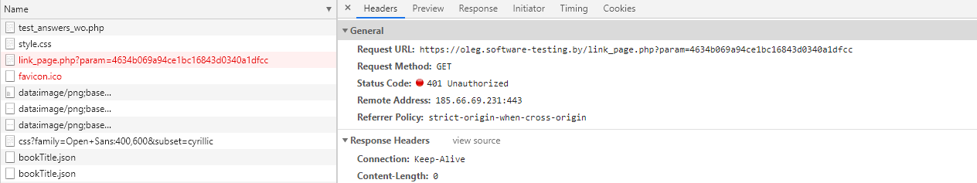

Link#6 - 403 Forbidden

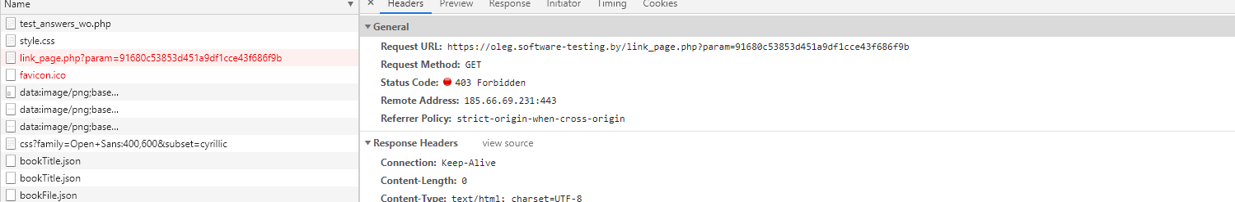

Link#7 - 503 Service Unavailable

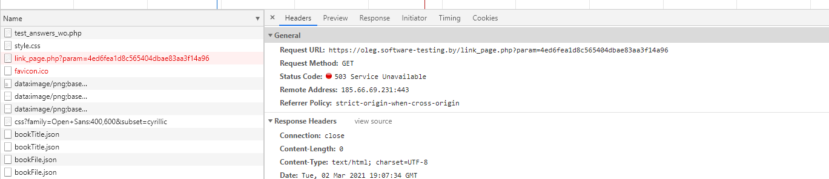

Link#8

